PART 1

1.

a.

7 Normalize the conceptual model.

1 Obtain a general description of company operations.

10 Load the database.

2 Create a description of each system process.

11 Test the system.

5 Draw a data flow diagram and system flowcharts.

6 Create a conceptual model using ER diagrams.

9 Create the application programs.

4 Interview the mechanics.

8 Create the file (table) structures.

3 Interview the shop manager.

b. Type of car (whether or not it’s a Silent Car), Parts Inventory, Workers (for the location), Independent car Information (including which center it is)

c. The data directory will give the people using the database the information about how the different modules are connected and how the database works. For example, if you put in the location/center that the current car is at then it should only write to that center and only write to that centers inventory of parts.

d. As stated above multiple modules will be linked together since there are multiple centers all with there own cars, workers, and inventory of parts. The manager needs to know how to enter in data and subtract parts from his center so that there is a problem with the recorded data.

e. The best approach is to make a design that does not have overlaps in order to have the lease amount of errors between data in the system. This is achieved through dummy proofing everything so that no one from one center can enter in their worker details and then takes parts from the inventory of another different center.

f. First report will be cars that have been added into the system for that center, along with there ids and short description. Second there will be a report of who worked on the car, and what they did for what ever amount of time. Third there needs to be a report of items added and taken from the parts inventory of the center so you can keep track of what the inventory is like. These report will mostly be used by the manager but also can be used by the mechanic in order for them to track what has been don’t to the car along with what parts have been used or taken.

4. The System would be rather similar but instead there would be 3 main modules. The teacher, class, and student. All the information could be rapped up in these three modules and would be easy and effective to get to. All teacher information would be contained and would overlap with what classes that they are teaching. Then the students would be registered into a certain class whose information details what teacher there is. So if you wanted to see all the students that were in a certain teachers class all you would have to do is compare the students with the same teacher and class id.

6.

a. perfective

b. adaptive

c. corrective

PART 2

1. 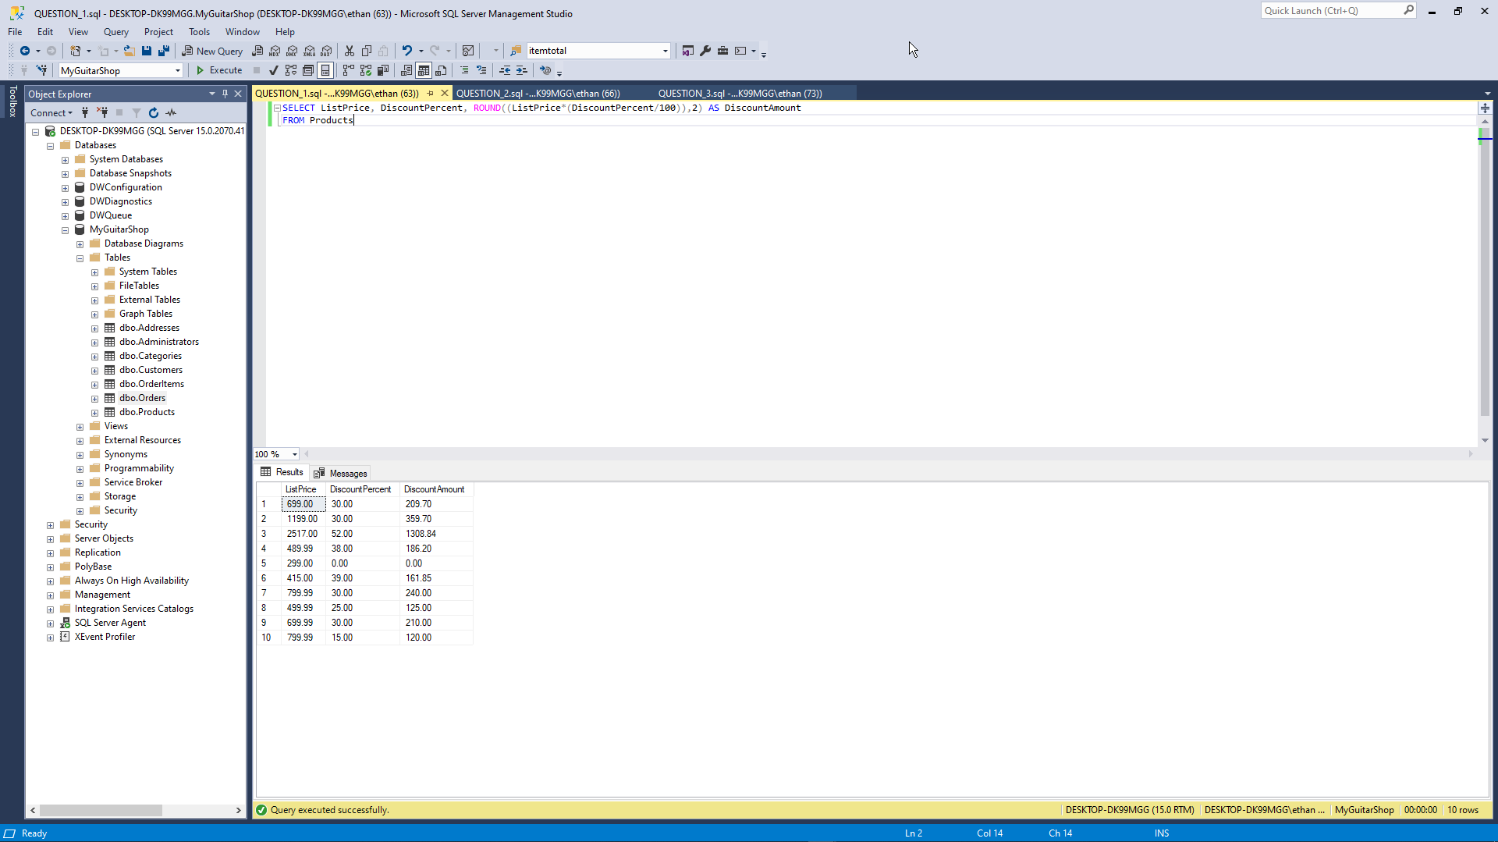

2. 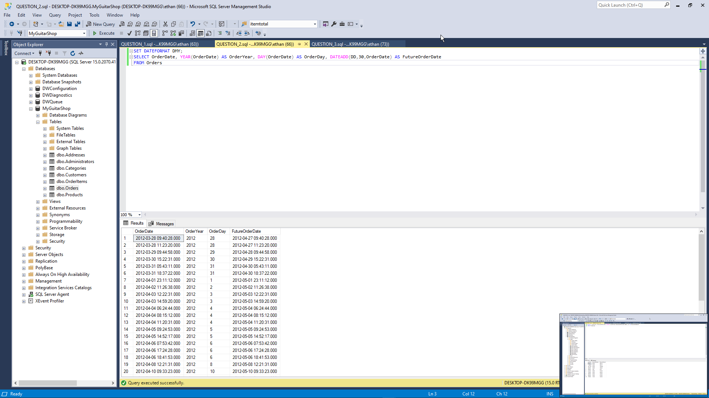

3. 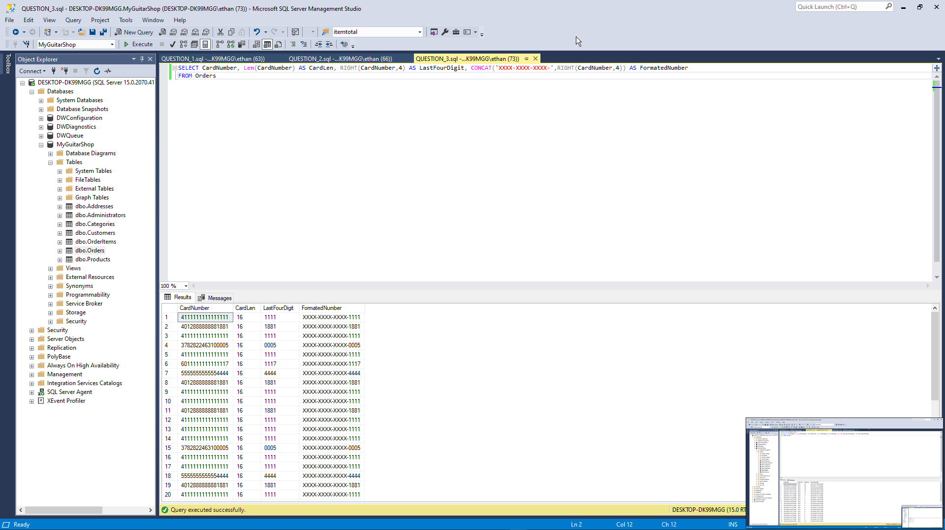

4. 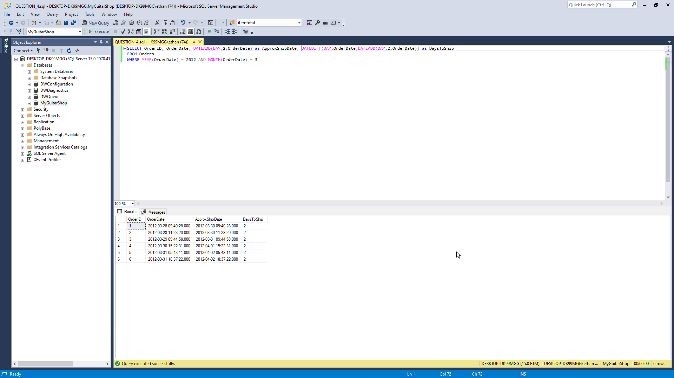

PART 3

1. 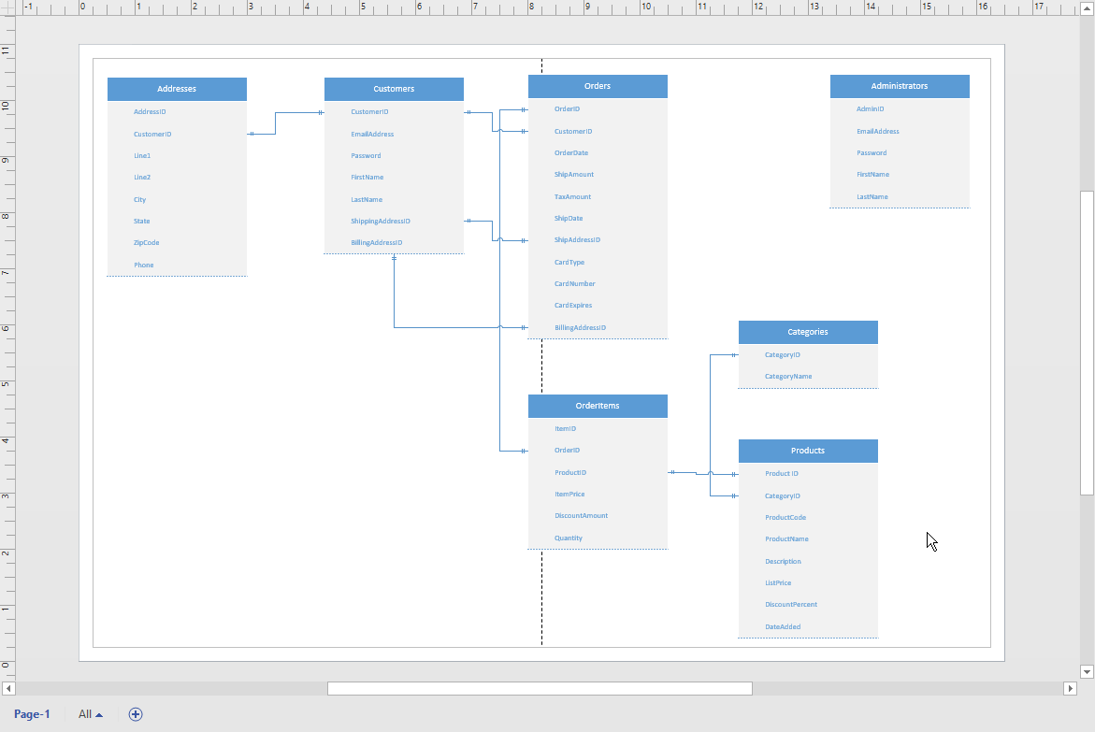

2. 